Machine Learning: Assignment 5

Student Name: Pooja Moosapet

Network id : 700743713

Semester: Spring

Course id: CS 5710

CRN: 22003

**GitHub Link**: https://github.com/PoojaMoosapet/Assignment-5

1.

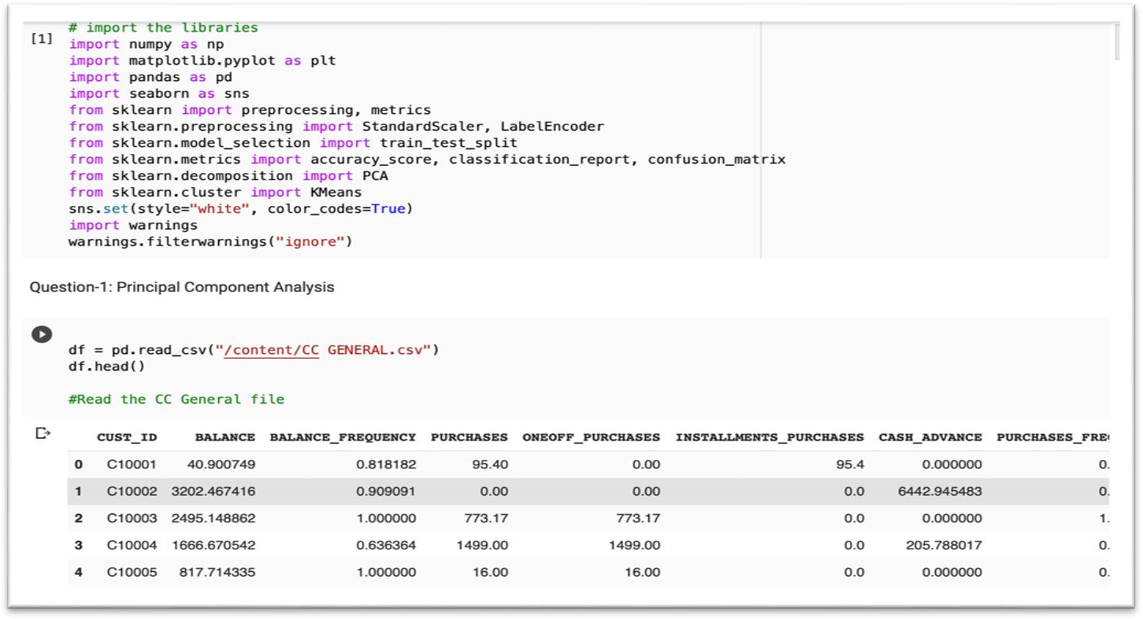

Check the features of the CC dataset.

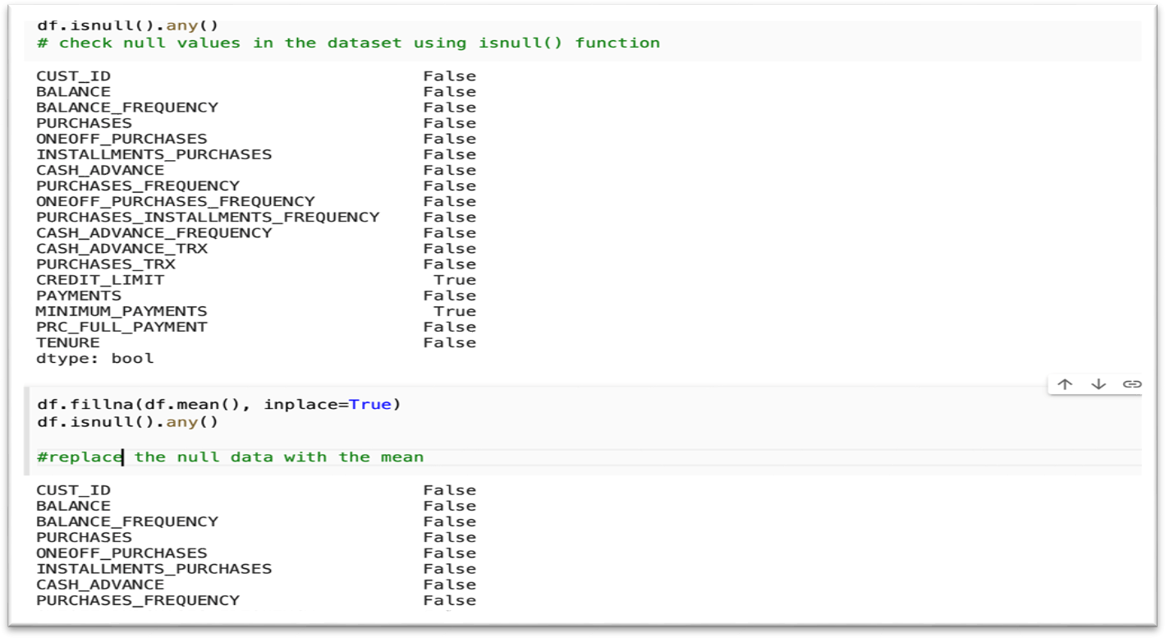

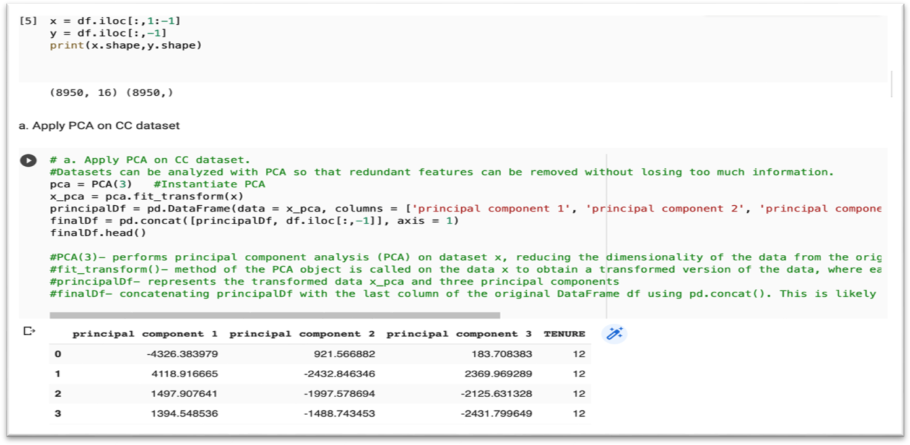EDA on the dataset. a.

Applying PCA on CC dataset.

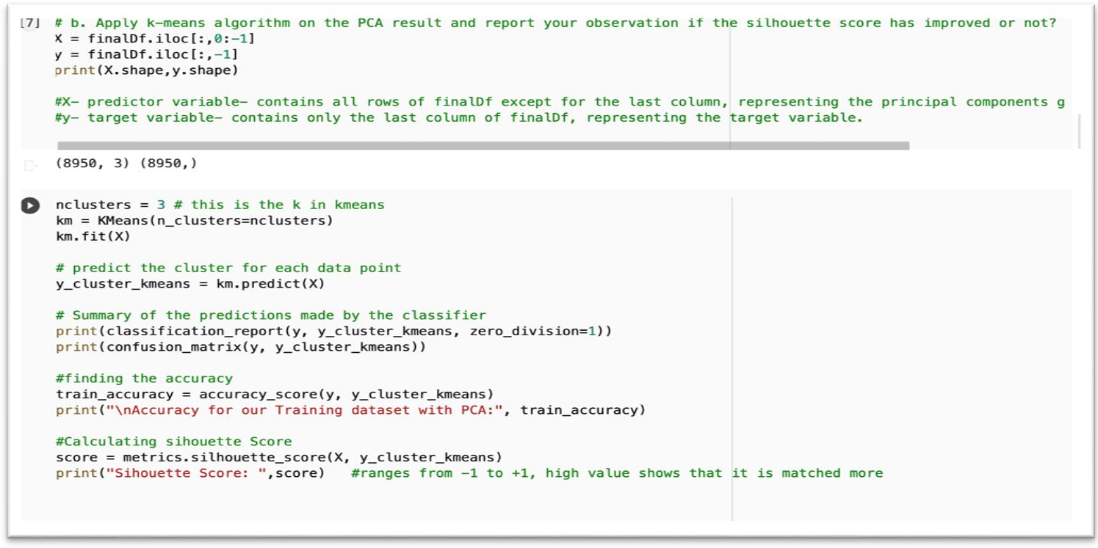b.

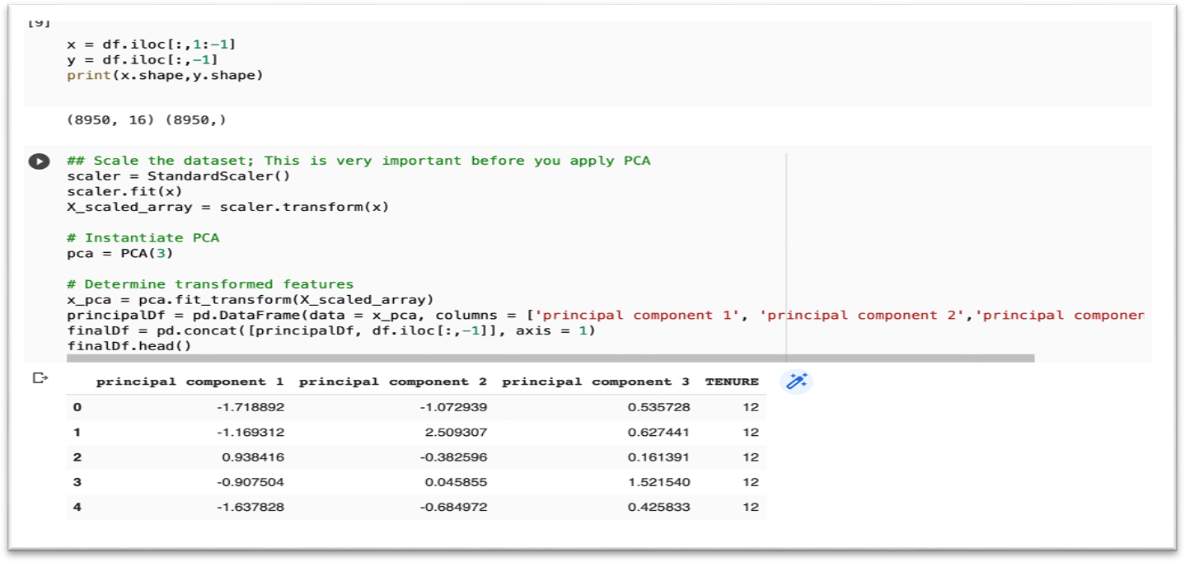Applying k-means algorithm on the PCA result. c.

Perform Scaling + PCA + K-Means.

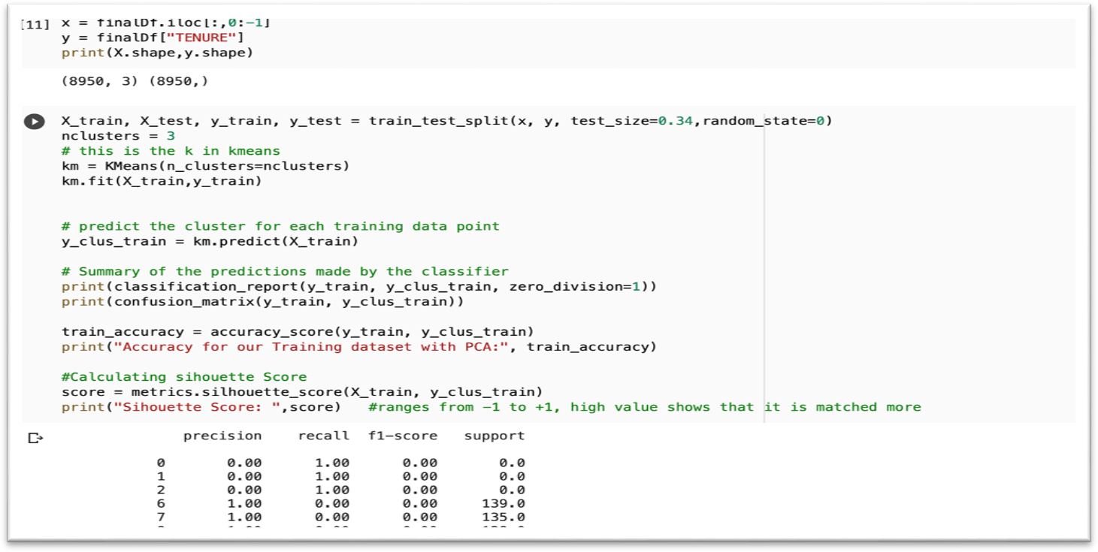

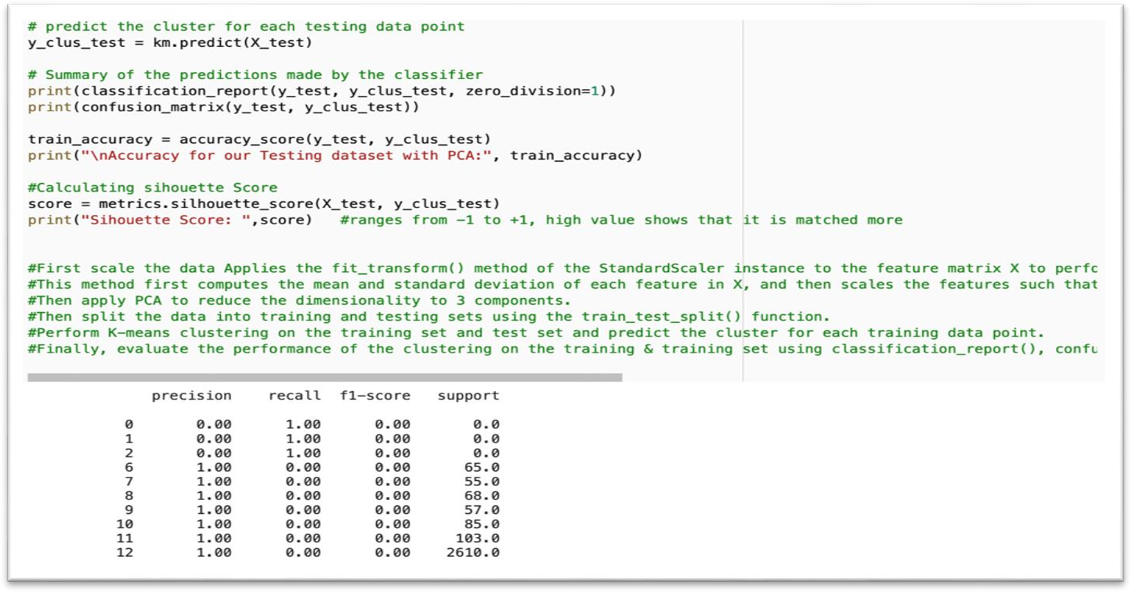

2.

a.

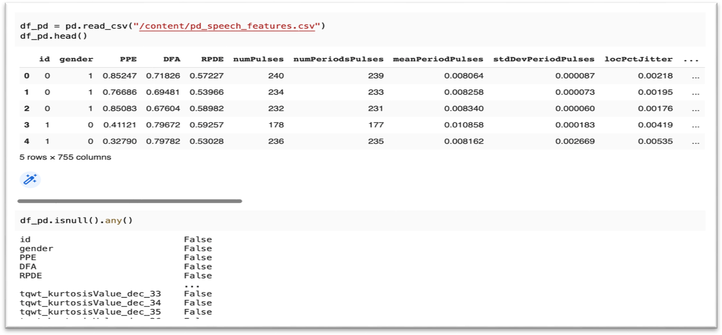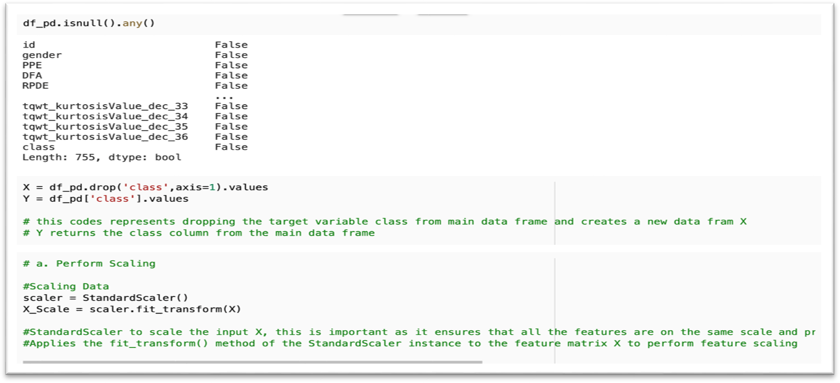

StandardScaler to scale the input X, this is important as it ensures that all the features are on the same scale and prevents features with larger magnitude from dominating the distance calculations.

b.

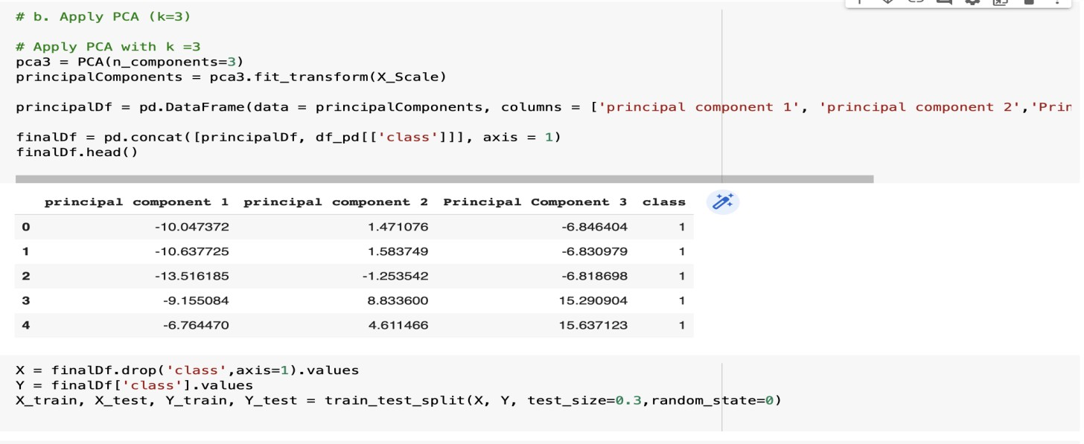

Apply PCA. c.

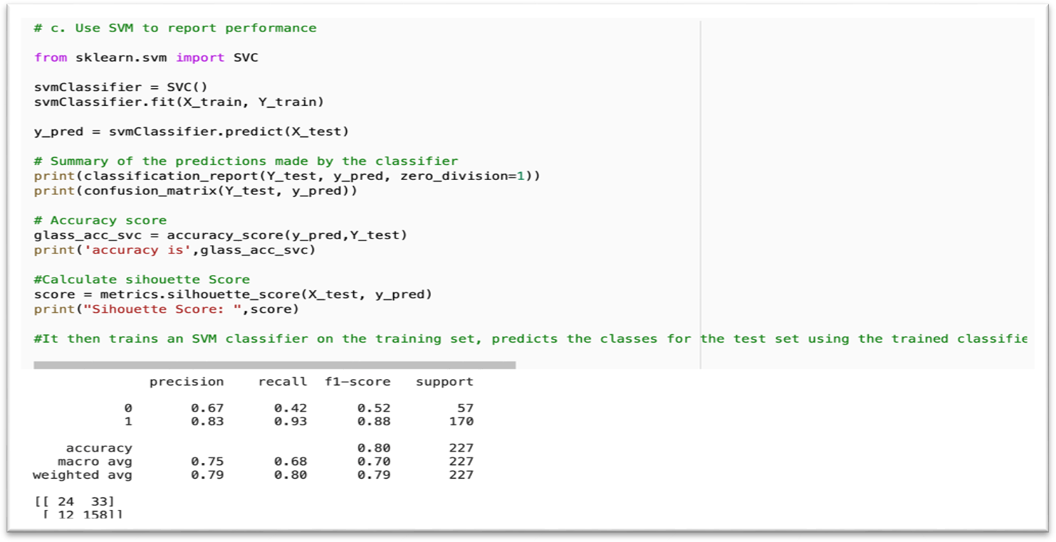

Apply SVM to check the performance.

3.

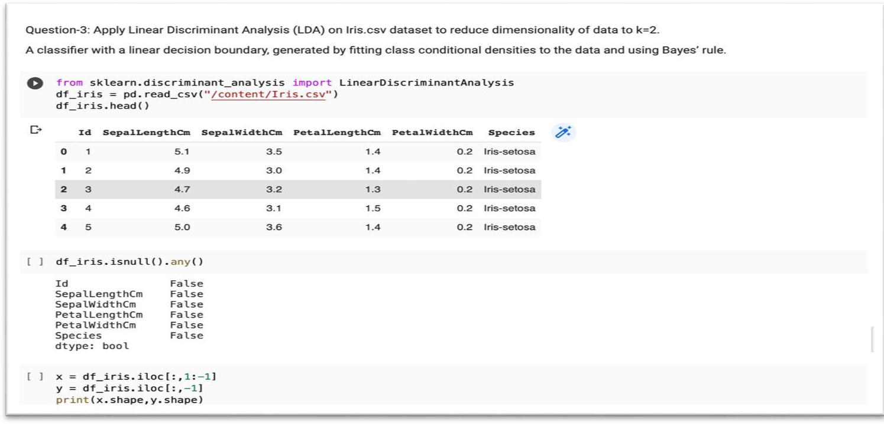Apply Linear Discriminant analysis on iris data set to reduce dimensionality of data to k=2

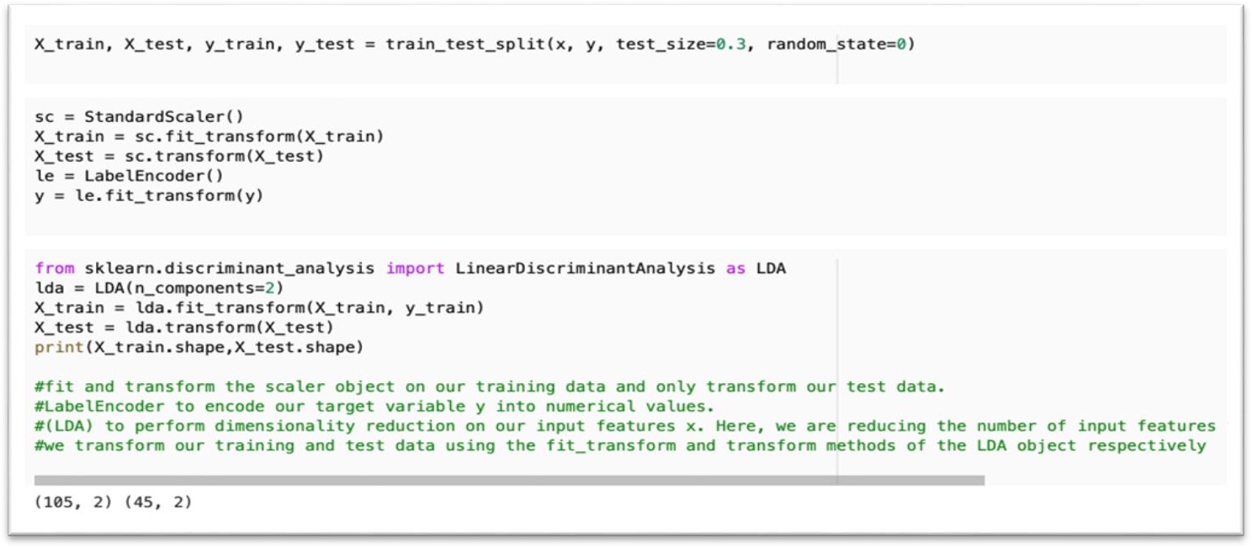

4.

